UN MOCK SESSION SCRIPT
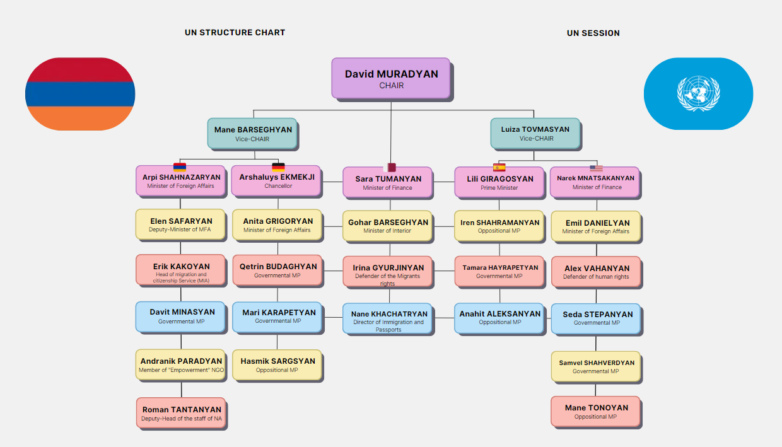
MURADYAN:
Dear presidency, delegates, dear colleagues, we are starting the inaugural session of the UN Security Council /the anthem of the United Nations, the anthem of the Republic of Armenia is playing/.
Sit down, please. The session was called to discuss the topic of "the problem of emigration and migration around the world". I wish all of us efficient work, and now the microphone is passed to the Deputy Speaker of the Security Council, so that she can present the names of the states participating in the discussion.
BARSEGHYAN:
Honorable presidency, dear colleagues. Please keep quiet, because now the states participating in the discussion will be presented: The Republic of Armenia, the Federal Republic of Germany, the State of Qatar, the Kingdom of Spain, the United States of America.
TOVMASYAN:
Honorable presidency, dear colleagues. I officially announce that the session of the UN Security Council is open. And now, be careful, because we are starting the "List of Speakers" queue. The queue.
The QUEUE: Armenia, USA, Qatar, Spain, Germany.
BARSEGHYAN:
The queue is now set. The delegation of the Republic of Armenia, the floor is yours.
The delegation of Armenia is speaking.
SHAHNAZARYAN:
Honorable chairs, esteemed delegates, as a head of the delegation and separately the minister of foreign affairs I would like to highlight the issue that brings us together as a matter of paramount importance to our nations’ immigration and migration policies. This topic profoundly shapes the trajectory of Armenia's future.
As we delve into this discourse, it is imperative to acknowledge the reality that approximately 1.2 million Armenians reside abroad, constituting nearly one-third of our total population. This diaspora underscores the pursuit of opportunities beyond our borders, be it for educational advancement, professional endeavors, or a higher standard of living.
Our government is steadfast in its commitment to implementing fair and equitable immigration policies. We aim to enhance multicultural cooperation and establish a system that not only welcomes those seeking to immigrate to Armenia but also prioritizes the well-being of our citizens.
SAFARYAN:
As a deputy minister of foreign affairs, I would like to continue with the topic of migration, both international and internal, which is a significant concern for Armenia. We will begin by addressing international migration. We must identify ways to foster sustainable development in rural areas to prevent this imbalance.
A large number of Armenians migrate to Russia, Europe, and the United States in search of employment opportunities and a better quality of life. However, in recent years, some have started returning to Armenia, particularly from Russia, due to economic challenges faced in those regions. Promoting seasonal migration, where individuals temporarily work in cities but return to their villages for harvesting, could be part of the solution.
KAKOYAN:
As a head of migration and citizenship service, I will concentrate on the consequences.
Indeed, labor migration is a growing trend. Many individuals leave for temporary work, primarily in Russia and Europe, although some decide to settle permanently.
The Armenian diaspora plays a vital role in supporting new migrants and contributes significantly to the economy through remittances. Enhancing the rural economy and developing infrastructure would make remaining in these areas more appealing.
PARADYAN:
As an NGO, our primary focus is on assisting migrants in safeguarding their rights abroad and helping them to reintegrate upon return. However, it is crucial to address the root causes of migration, such as unemployment and limited opportunities in rural areas.
NGOs can collaborate with the government to provide skills training and create opportunities in rural regions.
TANTANYAN:
As a representative of NA, I claim that the government is actively working on agreements with other countries to ensure the protection of migrant rights. However, internal migration remains a significant concern as well.
MINASYAN:
As a governmental member of parliament, I would like to emphasize that young people relocate from rural areas to cities like Yerevan in search of better opportunities. This results in overcrowding in urban areas and depopulation in rural regions. It affects the internal migration level.
The National Assembly is prepared to support policies that address both migration and regional development. Thank you for your attention, we yield our time to the chairs.
BARSEGHYAN:
Thank you very much. The second country in the queue is Germany on behalf of Her Excellency the Chancellor of Germany.
The delegation of Germany is speaking.
EKMEKJI:
Honorable chairs, esteemed delegates,
The Federal Republic of Germany and the state government under my presidency, has experienced significant changes in immigration patterns over the years. The issue of immigration has not only economic but also political and social ramifications, with public opinion sharply divided based on political affiliations. In this summary, let’s analyze the benefits and challenges of immigration in Germany using recent statistics and surveys.
GRIGORYAN:
Public sentiment in Germany regarding immigration is highly polarized, particularly along party lines. Based on a survey conducted in September 2023, different political party supporters view immigration quite differently. A majority of Greens supporters (68%) believe that immigration brings more benefits than disadvantages, while only 22% see it negatively. On the other hand, skepticism about immigration is much higher among conservative party supporters.
For instance, CDU/CSU voters largely perceive immigration as a disadvantage, with 70% holding this view compared to only 20% who see benefits. The far-right AfD party shows the most extreme stance, with a staggering 93% of its supporters believing that immigration presents more disadvantages, and only 6% seeing any benefits.
BUDAGHYAN:
According to the statements of the Parliament, we as members, would like to present data in percentage. In the 2013-2022 period, the most common reasons for immigration to Germany included asylum and international protection (27.9 %), employment (24.2 %), and family reunification (23.9 %). In addition, 8.2 % of those who immigrated since 2013 stated that they had come to Germany mainly to study or for education and training.
Among men, the most frequent reasons were protection (30.5 %) and employment (30.1 %), while women named family reunification (30.0 %) and protection (24.9 %) as the main reasons.
KARAPETYAN:
The data shows that while Germany has accepted millions of immigrants, public opinion remains divided, largely influenced by party politics and concerns about economic and social impacts. Immigrants from a wide range of countries bring diversity but also challenges in housing and social services. The growing number of immigrants from
Ukraine and other countries present both an opportunity for economic growth and a challenge in terms of public sentiment and resource allocation.
SARGSYAN:
Honorable Chair, dear delegates,
Thank you for allowing me to speak today.
I represent Germany and I am from the opposition party. Today, I will talk about migration and immigration, which is a big issue all around the world. In Germany, we have welcomed many people who left their homes because of war or other problems.
We believe in helping people, but we also see that too many migrants can create challenges. Our schools, hospitals, and cities sometimes become overcrowded, and it is hard for everyone to live well together. As the opposition, we think that migration must be managed more carefully. We need strong rules so people who come can work, learn the language, and be part of our society. Migration is a global issue, and no country can solve it alone. Thank you very much.
EKMEKJI:
Honorable chairs, esteemed delegates.
As we’ve noticed, migration and immigration is a widespread issue for the whole globe. So, we recommend you to unite around one ideology: we’re a big family of various nationalities and we must unite and work together to create a better future.
We express our gratitude and yield the time to the chairs.
TOVMASYAN:
The third country on the list is Qatar. The floor is yours.
The delegation of Qatar is speaking.
TUMANYAN:
Honorable chairs, esteemed delegates.
As the head of the delegation of the Arabic Republic of Qatar and separately the minister of finance, we’re gathered here to speak aloud about one of the biggest issues: migration and immigration.
Today, we will be presenting the topic of migration in Qatar, a key aspect of the country’s development and workforce.
People migrate to Qatar for various reasons, including seeking better economic opportunities, escaping conflict, or improving their quality of life. Many individuals leave their home countries in pursuit of higher-paying jobs and improved living conditions. In addition, migration is often driven by conflict.
The question of whether migration is beneficial or detrimental is complex. For sending countries, the loss of skilled workers can slow economic development. However, the receiving countries often experience economic growth, as migrant workers contribute to the labor force and help meet the demands of expanding economies.
BARSEGHYAN G:
As the minister of interior, I will present some data in percentage.
Qatar has consistently placed a high emphasis on migration as a key factor in its economic development. Each year, approximately 100,000 to 150,000 new migrants arrive in Qatar, depending on the nation’s economic needs. This number fluctuates based on large-scale construction projects and major international events, such as the FIFA World Cup.
The three largest migrant groups in Qatar are from India (698,100), Bangladesh (263,100), and Nepal (254,300). Other significant migrant populations come from countries such as Pakistan, Indonesia, Kenya, Nigeria, the Philippines, Sri Lanka, Sudan, Uganda, and others.
Through understanding the scale and impact of migration in Qatar, we can better appreciate its role in shaping the country’s economy and society.
KHACHATRYAN:
As the Director of Immigration and Passports in Qatar, our structure is responsible for managing the visa and passport processes for the country’s many migrant workers. These workers are essential to Qatar’s economy, especially in industries like construction and domestic work. Ensuring that migrants can easily apply for visas, renew them, and obtain residency permits is a crucial part of their ability to live and work in the country legally.
However, even with recent improvements, migrants still face problems related to their visas and passports. Under the old kafala system, workers needed their employer’s permission to leave the country, often trapping them in difficult situations. Although reforms were made in 2020, some employers continue to take workers’ passports or delay renewing their visas, which puts workers in a tough spot. Without valid visas or passports, these workers face the risk of being deported or imprisoned, and they have little power to seek help or return home.
While the system has improved, there are still serious issues that need to be addressed to ensure migrants are treated fairly and have the freedom to leave or change jobs without fear of retaliation from their employers.
GYURJINYAN:
Current Migration in Qatar: Migrants play a key role in Qatar’s economy, making up most of the workforce in several important sectors. As Qatar continues to grow and develop, especially with projects like the FIFA World Cup 2022, the demand for migrant labor has increased. Workers from countries like India, Nepal, Bangladesh, and the Philippines are vital to keeping Qatar’s major industries running. The main sectors that employ migrant workers include construction, domestic work, hospitality and tourism, retail and services, and manufacturing.
Construction: The construction industry is the largest employer of migrant workers in Qatar. Major projects, such as building stadiums, roads, and hotels, require a large number of workers. Migrants, especially from South Asia, take on difficult jobs, often in hot conditions. Even though Qatar is wealthy, construction workers usually earn low wages and work long hours.
TUMANYAN:
Honorable chairs, esteemed delegates. We consider the above-mentioned as an introduction. Later we’ll present our ways of solving and recommendations.
Thank you very much. We yield our time to the chairs.
TOVMASYAN:
Thank you. The next country on the list is Spain's delegation on behalf of Her Excellency, Prime Minister. The floor is yours.
The delegation of Spain is speaking.
GIRAGOSIAN:
As representatives of the Spanish government, we are here to address the complex and pressing issue of immigration and migration. Spain, situated at the crossroads of continents, has long been a destination for individuals seeking new opportunities and safety. Our approach to immigration is guided by a commitment to uphold human rights, ensure national security, and promote social cohesion.
HAYRAPETYAN:
We acknowledge the valuable contributions that migrants make to our economy and society while recognizing the necessity for effective border management and integration policies. Spain advocates for a balanced approach that respects both individual rights and the rule of law. We are dedicated to collaborating with our European and international partners to address the root causes of migration and to identify sustainable solutions for all.
SHAHRAMANYAN:
Honorable chairs, distinguished delegates,
As an opposition representative, I believe migration is both an opportunity and a challenge. In Spain, immigrants contribute to our economy and diversity, but we face pressure on public services and infrastructure.
Our current migration policies are overwhelmed. We need stronger border controls and better integration strategies, including education and employment access for newcomers. But more importantly, we must address the root causes of migration, such as conflict, poverty, and climate change, through international cooperation.
We advocate for a balanced approach—ensuring security and fairness for all while upholding human rights and Spain’s obligations. Thank you.
ALEKSANYAN:
Honorable chairs, esteemed delegates,
I will speak on behalf of the opposition. We acknowledge the importance of migration, but we must address the challenges it brings. Our country has seen a rise in immigration, and while diversity can strengthen our society, we must also consider the impact on our economy, public services, and security.
We believe that Spain must have stricter immigration controls. Our borders need to be secure, and we should ensure that only those who meet certain requirements can enter. We must also provide support for legal immigrants who contribute to our society, but we cannot ignore the pressure on our housing, healthcare, and job markets.
At the same time, we believe in international cooperation. Spain cannot solve these challenges alone. We must work with other countries to find balanced solutions that protect our interests and respect human rights. Thank you, we yield our time to the chairs.
TOVMASYAN:
Thank you, Republic of Spain. The next and the last on the speakers’ list is the United States. The floor is yours.
The delegation of the United States is speaking.
MNATSAKANYAN:
Honorable chairs, and esteemed delegates, as the head of the delegation and the minister of finance, I will present the current situation.
The most significant factor shaping the U.S. economy is immigration. While it presents both opportunities and challenges, it undeniably drives economic growth. Immigrants play a crucial role in sectors such as technology, healthcare, agriculture, and construction, maintaining U.S. competitiveness globally.
One key benefit is their contribution to offsetting the aging workforce. A steady flow of young immigrants is essential for sustaining industrial momentum, fostering innovation, and ensuring the stability of social security systems.
Moreover, immigrants often establish small businesses, creating jobs and stimulating local economies. Their contributions spur innovation and entrepreneurship while enhancing the cultural richness of the nation. Immigration also increases consumer demand, further strengthening the economy.
In essence, immigration is vital for U.S. economic vitality. With the right policies, it enhances growth, fills labor gaps, and stimulates innovation. Though challenges exist, the long-term benefits are undeniable, and immigration should be recognized as a key driver of economic prosperity.
DANIELYAN:
As the minister of foreign affairs, I understand that our immigration policies reflect not only our national security needs but also the values that define America.
For generations, America has been a land of opportunity, welcoming individuals from diverse backgrounds seeking safety and a better life. Immigrants have enriched our society, driving innovation and contributing to our economy in countless ways.
Our approach must be fair and inclusive, providing clear pathways for legal entry while ensuring the integrity of our borders.
As we move forward, let us reaffirm our dedication to justice and equality for all. Together, we can create an immigration system that embodies the hope and opportunity that define America. Thank you.
STEPANYAN:
The ruling party emphasizes a balanced approach to immigration, focusing on securing borders while also recognizing the contributions of immigrants to the economy and society. We advocate for a fair immigration process that prioritizes skilled workers, supports family reunification, and provides pathways to citizenship for those already contributing to our communities.
Our goal is to create a system that fosters safety, economic growth, and inclusivity while addressing the challenges of illegal immigration through effective policies and international cooperation.

VAHANYAN:
In America, immigrant human rights are protected by laws and the Constitution. These rights include fair treatment, due process, and access to legal help. Many groups work to support immigrants, fighting against unfair deportations, family separations, and discrimination. However, changing government policies can challenge these rights. Many immigrants also struggle to access education and healthcare. The issue of pathways to citizenship is important, as many want a secure future.
Additionally, the treatment of migrants at the U.S.-Mexico border raises serious concerns. Ongoing efforts aim to ensure fairness and dignity for all immigrants, highlighting their valuable contributions to society.

TONOYAN:
As a member of the US opposition, I stand here today with concerns about our current immigration policies. We believe that the system is broken and needs urgent reform. Millions of people enter our country each year, both legally and illegally. While immigration has helped build America, we must ensure it is done safely and fairly.
First and foremost, we need stronger border control to protect our national security. We cannot allow illegal immigration to continue without action. At the same time, we must improve the process for legal immigration. Those who follow the rules and contribute to our society should not face endless delays or discrimination.
We must work with other countries to find global solutions. Thank you.

SHAHVERDYAN:
I represent the opposition in the United States, and we have concerns about how immigration is handled in our country. We believe that while immigration is important, it must be controlled. We need stronger borders to protect our jobs and security.
Some people come to the U.S. illegally, and this can be dangerous for everyone. We want a system that helps people follow the rules and enter legally. At the same time, we need to make sure our citizens have jobs and feel safe.
We do care about people from other countries, but our priority is to protect the United States first. Thank you, we yield our time to the chairs.
MURADYAN:
Esteemed delegates, dear colleagues. We have finalized the 'List of Speakers.' According to protocol, I would now like to prepare for the debates. Dear colleagues, is there any country that wishes to propose a debate on a specific topic with a designated time limit?

